Activity two
Cross section of a tree

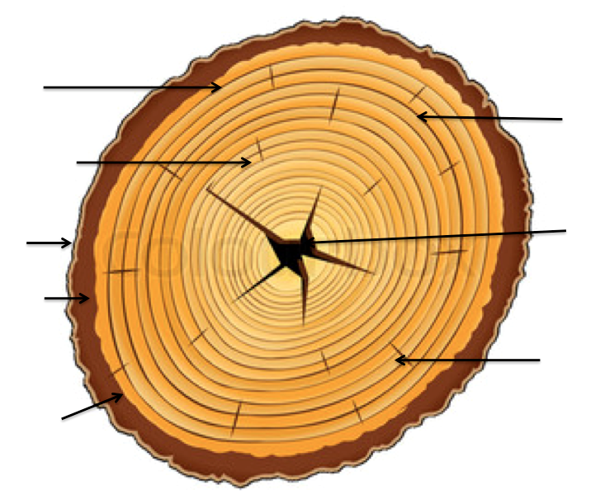

Sapwood
Heartwood
Dead bark
Live Bark
Cambium Layer
Growth Rings
The Pith
Medullar

